*Florida International University*

*School of Computing and Information Sciences*

Software Engineering Focus

Feature Document

User Story ID #146

**Name:** Remove Fellowship

**Team Member(s):** Winicius Siqueira, Alfredo Morales

**Project:** Fellowship Management 1.0

**Product Owner(s)**: Robert Zurita

**Mentor(s)**: Mohsen Taheri

**Instructor**: Masoud Sadjadi

**User Story Name: Remove Fellowship**

* Description: As an Admin User I would like to remove a fellowship so that I can remove fellowships that are past its deadline.

Acceptance Criteria

* The Admin User is able to remove a fellowship. Once the fellowship is removed it will no longer appear anywhere on the website.

**Use Case**

* Name: Remove Fellowship
* Actor: Admin User
* Preconditions: The Admin User has logged in and is in the /admins/fellowships/ page.
* Description <Flow of events>: The Admin User clicks the “Delete” link for a fellowship. A prompt will appear asking the user “Are you sure?”. If the user clicks “OK”, then the fellowship will be deleted from the fellowship list, and the page will reload. If the user clicks “Cancel”, then the fellowship will not be deleted from the fellowship list.

**Use Case Diagram <**you can use draw.io**>**

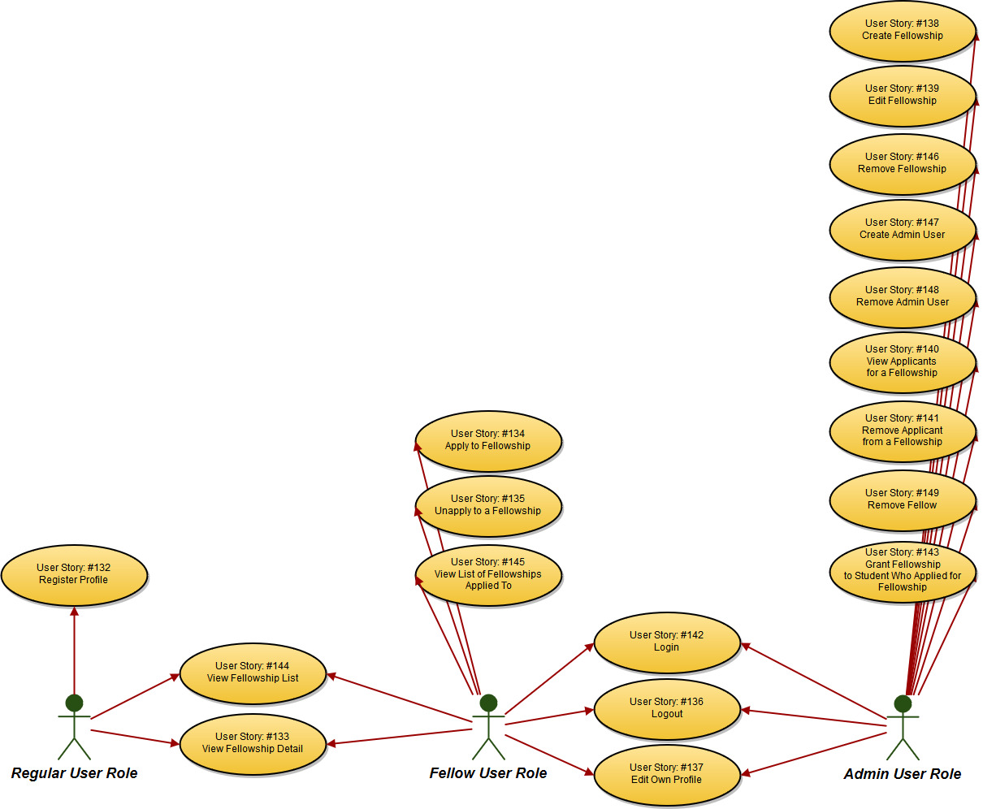

**Sequence Diagram**

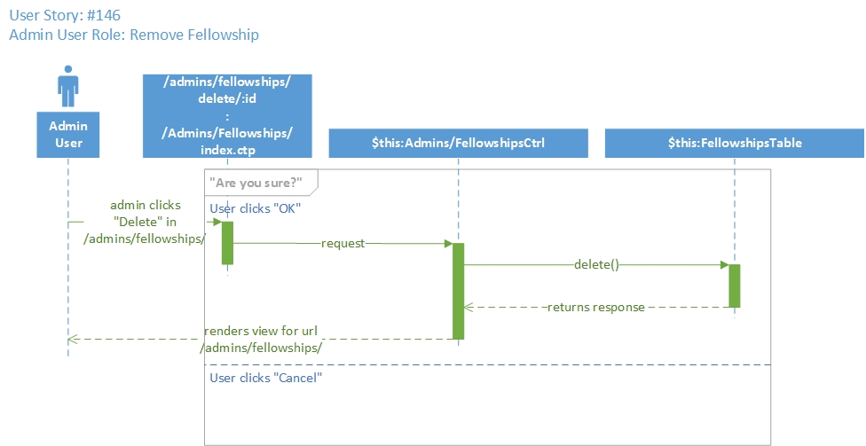

**Class Diagram**

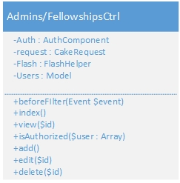

**Unit Test**

* Test case ID: testRemoveFellowshipPageLoad146
* Description/Summary of Test: This test case checks that the following URL:

/admins/fellowships/ contains the strings “Delete” and “/admins/fellowships/delete/”.

* Pre-condition: The session variable contains id=1 and username=’w’ and role=’admin’.
* Expected Results: The following page loads properly: /admins/fellowships/ and the page contains the strings “Delete” and “/admins/fellowships/delete/”.
* Actual Result: The following page loads properly: /admins/fellowships/ and the page contains the strings “Delete” and “/admins/fellowships/delete/”.
* Status (Fail/Pass): Pass

**Integration Test**

**Visual User Guide** <like one or two screenshots of the feature. For the hardware project, a photo of device is required>

